Please call or text at (330) 305-6500 with any questions or concerns!

Dental Cleaning
What to expect after surgery:
Your pet may experience
- Grogginess or irritability for 24 to 48 hours
- Unsteadiness for 12-24 hours
- Decreased appetite for 24 to 48 hours
- Bowel changes for 24 to 48 hours post coming home. Anesthesia can slow down the intestinal tract and cause mild constipation or even cause diarrhea. If either persists beyond 48 hours please contact the clinic.
- Mild cough 2 to 3 days after surgery from the anesthetic endotracheal tube causing a small amount of irritation to the throat.
- Mild bruising or mild clipper rash at the intravenous catheter site located on the front leg.

THE PROCEDURE:
Your pet underwent general anesthesia to have his/her teeth cleaned and polished with an ultrasonic scaler.
What happened during the veterinary dental procedure:
- Teeth scaling to remove tartar and plaque
- Teeth polish
- Gum irrigation to remove debris and remaining polishing paste
- Application of a foam Fluoride treatment

FEEDING GUIDELINES FOLLOWING THE PROCEDURE:
- Only offer a small amount of food and water the night of the procedure as your pet may be groggy.
- If your pet is back to normal the next morning and has not vomited its meal from the night before, start feeding their normal amount of food and water.
- Feed soft or softened food over the next 1-2 days. If your pet’s normal meal is dry food, simply moisten it with warm water or low sodium chicken broth and allow soaking for 15 minutes before offering it to your pet.
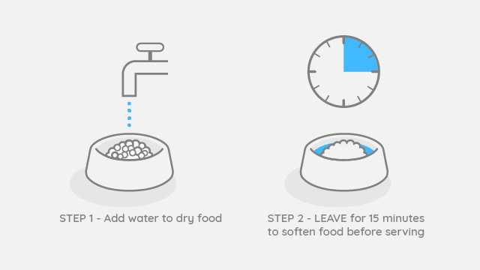

WHEN TO CALL THE VETERINARIAN
- If your pet stops eating for more than 24 hours
- Vomiting constantly
- Lethargic
- Lots of blood coming from the mouth

MEDICATION
If your pet was prescribed medication, please administer the medication as per the directions on the label.

PREVENTATIVE CARE:
We recommend ongoing dental homecare to help try to protect/prevent their teeth from future dental disease. Even after a thorough dental cleaning under general anesthesia, plaque can start to form on tooth surfaces within 24 hours.
Some options for dental care going forward:
- Dental chews
- Brushing its teeth with pet-approved toothpaste 2 to 3 times a week, if not daily (if possible)
- Dental rinses
- Chew toys
All preventative care should be started or restarted 3 to 4 weeks after the Dental procedure.

