Please call or text at (330) 305-6500 with any questions or concerns!

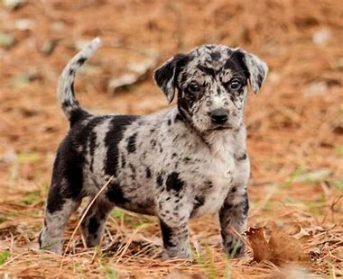

Canine Spay - Discharge Instructions
Your dog is recovering from major surgery and anesthetic and requires continued support and nursing care at home to ensure a successful outcome. During the recovery period of approximately 14 days, home care is extremely important.

WHAT TO EXPECT AFTER SURGERY
Your pet may experience:
- Grogginess or irritability for 24 to 48 hours
- Unsteadiness for 12 to 24 hours
- Decreased appetite for 24 to 48 hours
- Bowel changes for 24 to 48 hours post coming home. Anesthesia can slow down the intestinal tract and cause mild constipation or even cause diarrhea. If either persist beyond 48 hours, please contact the clinic.
- Mild bruising and discomfort a day after surgery on the incision site and at the intravenous catheter site which is located on their front leg
- Mild cough 2 to 3 days after surgery from the anesthetic endotracheal tube causing a small amount of irritation to the throat
- Mild clipper rash at the surgery site or at the intravenous catheter site

ACTIVITY
We strongly recommend strict confinement for the 14 days following surgery. Keeping your pet indoors and taking them outside to the bathroom on a controlled leash will help you manage the exercise restrictions. If you need to leave your pet alone, always keep confined to a crate, small room or an area in the home.
Strict confinement means:
- No jumping
- No running
- Minimal to no stairs, larger breeds especially may need to use a few stairs to go in and out and that is acceptable
- No rough playing
- No long walks or hikes
It's important to note that excessive activity can cause friction to the incisional area and lead to possible opening of the incision, injury or serious complications that could result in failure of the surgical incision to heal and may lead to further surgery.

INCISION
The area around the incision will have been clipped and sterilized prior to surgery.
The incision will be located on the belly (see image).
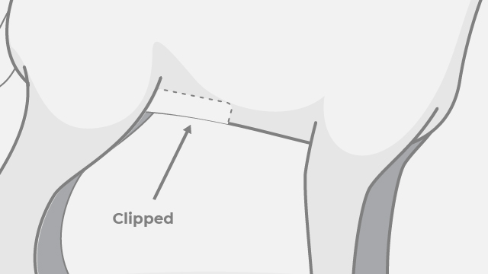
Please check the incision daily. Some slight bruising and inflammation are expected just around the incision for the initial 2 to 3 days post-surgery. The skin may appear inflamed for a few days and is referred to as a clipper rash. The Doctor closed the incision site with surgical tissue glue and the area will look almost "Pinched" together from the glue, this is normal.
If you notice any of the following signs, please contact the clinic.
- Increasing or spreading redness
- Swelling or extremely "Puffed out" appearance
- Discharge or drainage
- Any excessive bleeding
- A foul smell coming from the incision
The only sutures that were placed by the Doctor are internal and they are absorbable. The body breaks those down over 3-to-4-month time period. In that time, we can see what we call a "suture reaction" happen. That is where the body overreacts to the internal sutures placed and tries to push them out. This will look like a bump where the incision site was and can look like a pimple about to erupt. If you notice this, please call the clinic and we will take a look. Generally, antibiotics will be dispensed and over time the area will spontaneously resolve.

YOUR PET IS BEING SENT HOME WITH AN ELIZABETHAN COLLAR (SEE IMAGE). THIS PREVENTS LICKING AT THE INCISION AREA. IT SHOULD BE KEPT ON FOR THE FULL RECOVERY PERIOD OF 14 DAYS. LICKING CAN LEAD TO OPENING OF THE INCISION WHICH COULD CAUSE AN IMMEDIATE NEED FOR INCISIONAL REPAIR. THIS COULD POSSIBLY LEAD TO AN ADDITIONAL CORRECTION PROCEDURE THAT MIGHT BE MORE CHALLENGING THAN THE INITIAL PROCEDURE.
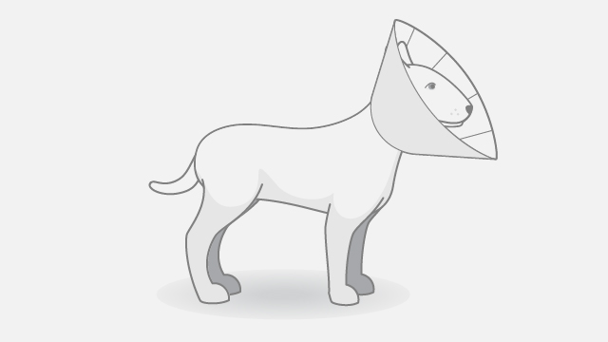
It's important to avoid bathing and grooming for 14 days post-surgery. We do not want the incision submerged in water seeing as that can soften the surgical glue and cause the incision to open.

DIET
A general anesthetic can make patients drowsy and nauseous. We recommend the evening after the surgery to feed your pet half the amount of food they normally receive and to limit water to small amounts at a time to help prevent further nausea or any vomiting. If any vomiting persists beyond 48 hours, please contact the clinic

MEDICATIONS
Your pet was given a 24-hour anti-inflammatory pain medication the morning of surgery.
- If pain medications were sent home, please follow the dosage instructions on the prescription label and start the morning after surgery with a full meal. If pain medications were not required or sent, please look for signs of pain/discomfort i.e., hunching, excessive yelping/crying, extreme lethargy, weakness, or lack of mobility.
- If antibiotics were prescribed or required by the Doctor post-surgery, please follow the dosage instructions on the prescription label that is sent as well. They are to be started the morning after surgery and always given with a full meal, regardless of the type of antibiotic prescribed.

